**Expert ID/Name: Nstructive**

**Date: 20-Nov-2020**

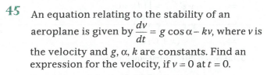

**Answer:**

|  |
| --- |
| **Section 1:** Algorithm/Theorem Reminder / A tip for solving these type of questions |
| **Tips:**  1 .Integrating factor of is .  2. General solution of is |

|  |
| --- |
| **Section 2:** Step-by-step answer |
| Given: The differential equation is,  ,Where is velocity and are theconstants.  To find: The Particular solution of given that.  Step 1:   |  |  | | --- | --- | | Instruction | Convert and Compare the given differential equation with | | Calculation | Compare with |   Step 2:   |  |  | | --- | --- | | Instruction | 1. Integral factor of is. | | Calculation |  |   Step 3:   |  |  | | --- | --- | | Instruction | 1.General solution of is | | Calculation | When then    Hence the solution is | |

|  |
| --- |
| **Section 3:** |
| Final answer: The expression of given that is. |